# Office 365: Create a task in Exchange Online

Summary:  The solution in this sample demonstrates how to use Exchange Web Services (EWS) Managed API to create a task in Office 365 Exchange Online, showing how other Exchange 2013 objects may be managed.

## Description of the sample

The purpose of this sample is to demonstrate how an ASP.NET Model-View-Controller (MVC) application uses Exchange Web Services (EWS) Managed API to create a task in Office 365 Exchange Online. The sample uses the email ID and password from the login to authenticate the credentials; the task title and message entered are used to call the web service to create the task. When the task is created, a list of the current tasks entered for the given credentials is displayed.

## Prerequisites

This sample requires the following:

* An Office 365 Developer Site.
* An Exchange Web Services (EWS) Managed API; see [Microsoft Exchange Web Services Managed API 2.0](http://www.microsoft.com/en-us/download/details.aspx?id=35371).
* Visual Studio 2012 installed on your computer.
* Office Developer Tools for Visual Studio 2012 installed on your computer.

## Key components of the sample

The sample zip file contains the following:

* A Visual Studio 2012 solution named O365_managingtasksusingEWS_cs that contains the code for the ASP.NET application.

## Configure the sample

1. Open Visual Studio 2012 with administrator privileges.
2. On the File menu, click Open, and then click Project/Solution.
3. Navigate to the folder where you unzipped the O365_managingtasksusingEWS_cs.sln file, select the file, and click Open.

## Build the sample

Press F6 to build the sample.

## Run and test the sample

1. Click F5 to run the application. A login dialog box opens; make sure that the browser version of the application is not earlier than Internet Explorer 8.
2. Enter the following data:
3. For Task creator Email ID and Password, enter your Office 365 email ID and password.
4. For Task Title, enter any title for your task.
5. For Task Message, enter any message text for the task.
6. Click the Create and Display Task button to create a new task for the Office 365 user.
7. After several minutes, the complete list of tasks for the user entered is shown appended to the web page, as shown in the following figure.

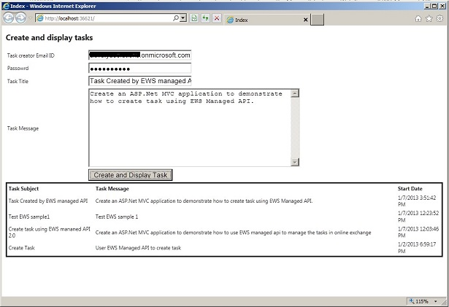

1. The new task can also be verified by logging in to the Office 365 site. Click the Outlook section, and then click the Tasks section to display all tasks, as shown in the following figure.

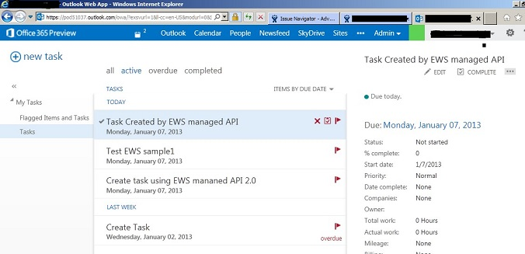

## Troubleshooting

The following table lists common configuration and environment errors that prevent the sample from running or deploying properly and how you can solve them.

| Problem | Solution |
| --- | --- |
| 0x800a1391 - JavaScript runtime error: 'JSON' is undefined | Make sure your browser version is set to Internet Explorer 8. |

## Change log

| Version | Date |
| --- | --- |
| First version | February 28, 2013 |

## Related content

* [Explore the EWS Managed API](http://msdn.microsoft.com/en-us/library/exchange/dd633710(v=exchg.80).aspx)
* [Working with the EWS Managed API](http://msdn.microsoft.com/en-us/library/exchange/dd633696(v=exchg.80).aspx)